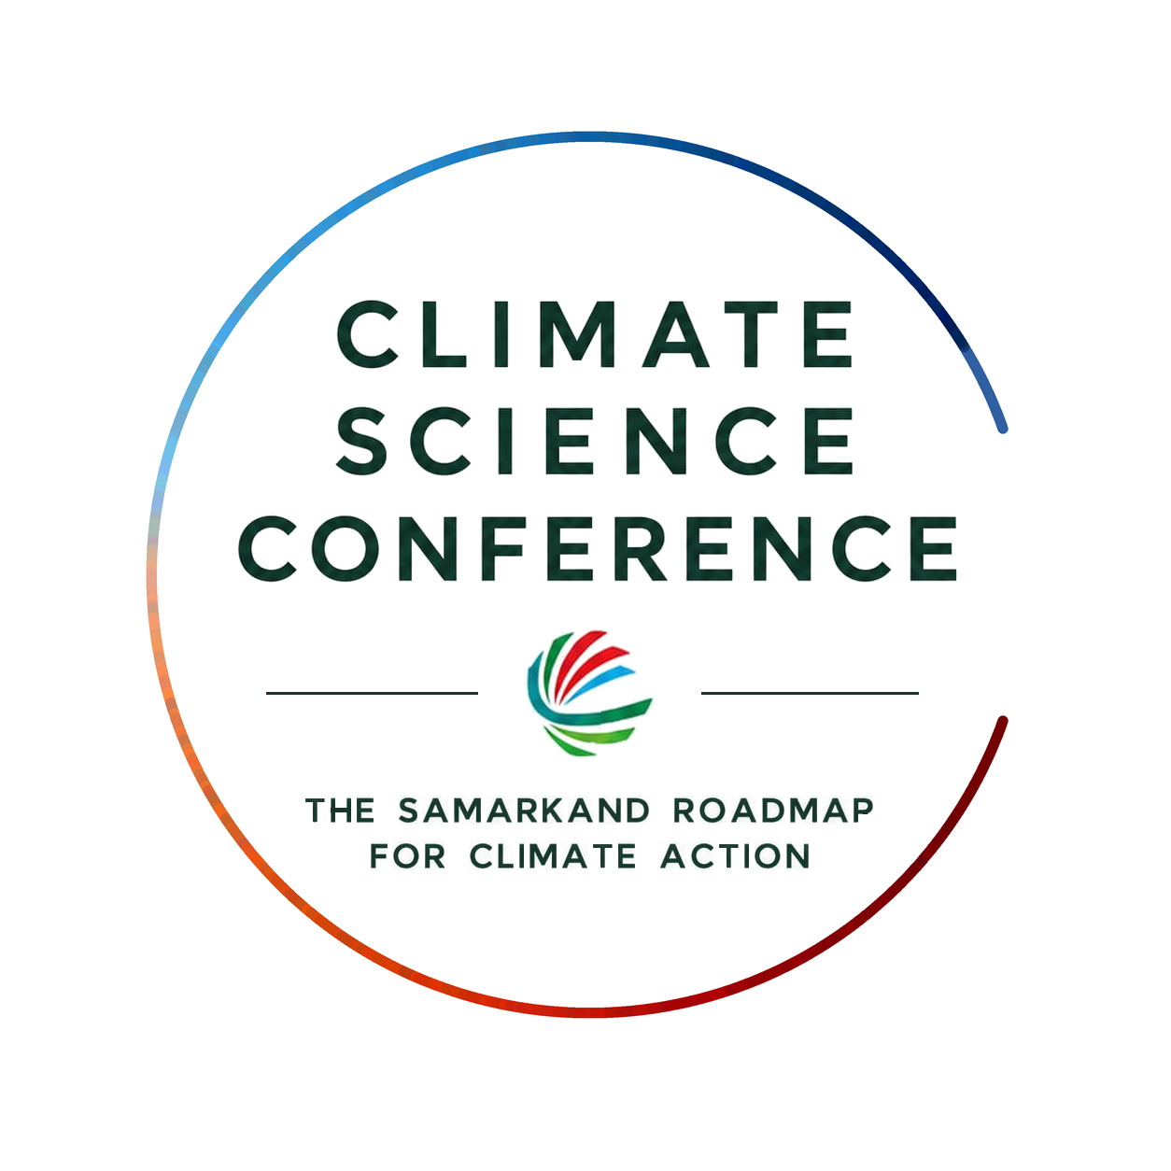
PROGRAMME (DRAFT)
“Science, Innovation and Cooperation for a Climate-Resilient Central Asia”
14 August 2026 | Green University, Tashkent, Uzbekistan

MAIN ORGANIZERS
  National Committee on Ecology and Climate Change of the Republic of Uzbekistan | 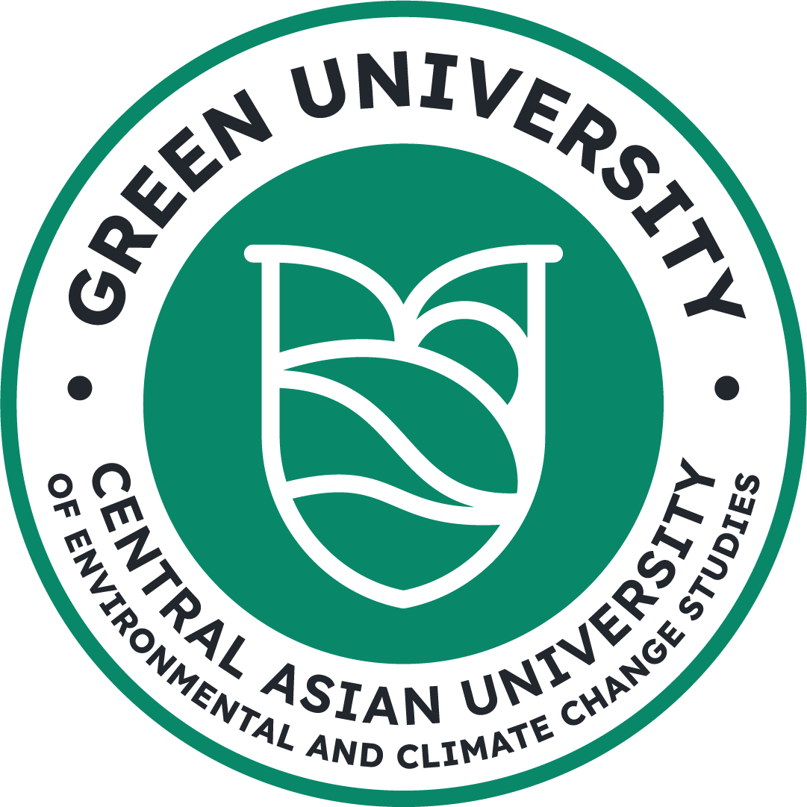  Central Asian University of Environmental and Climate Change Studies  (Green University) | 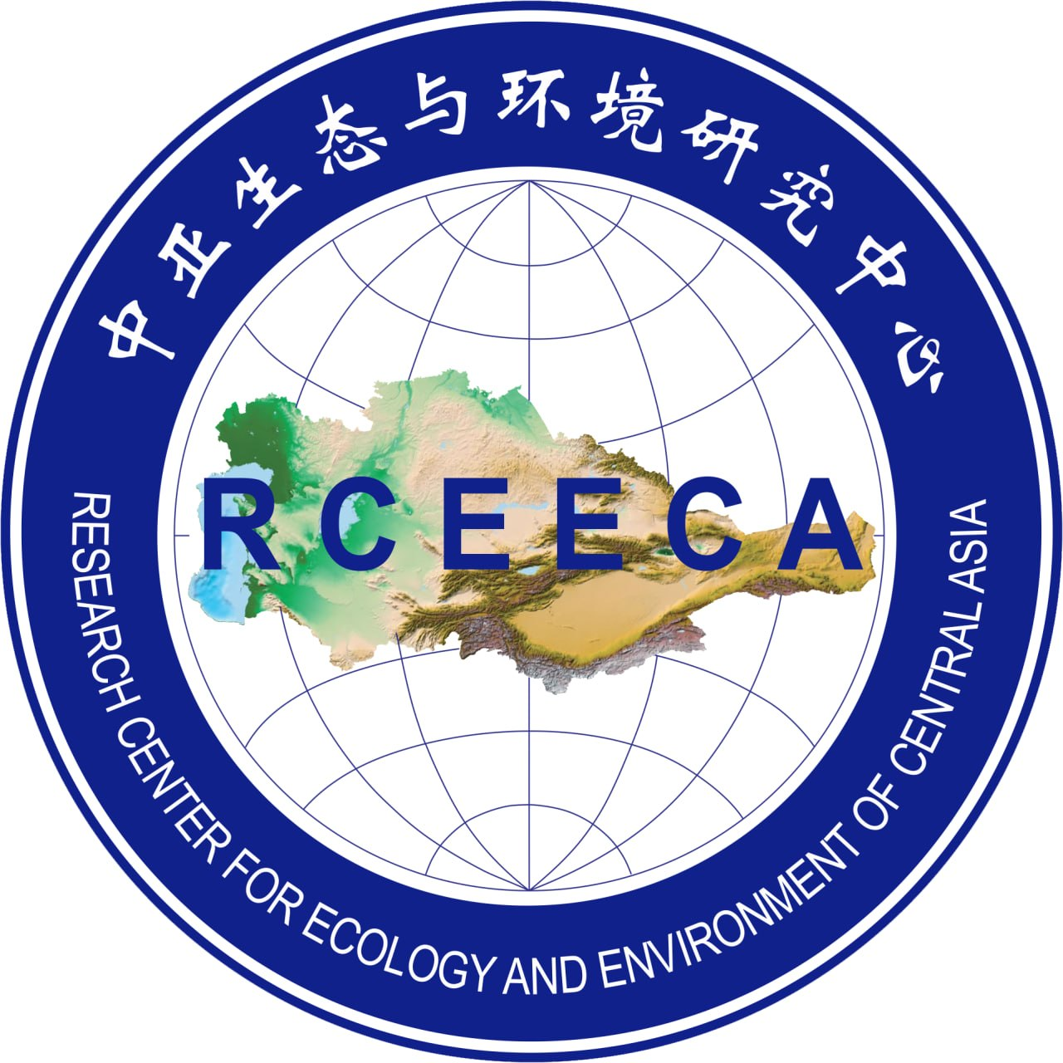  Research Center for Ecology and Environment of Central Asia (RCEECA)

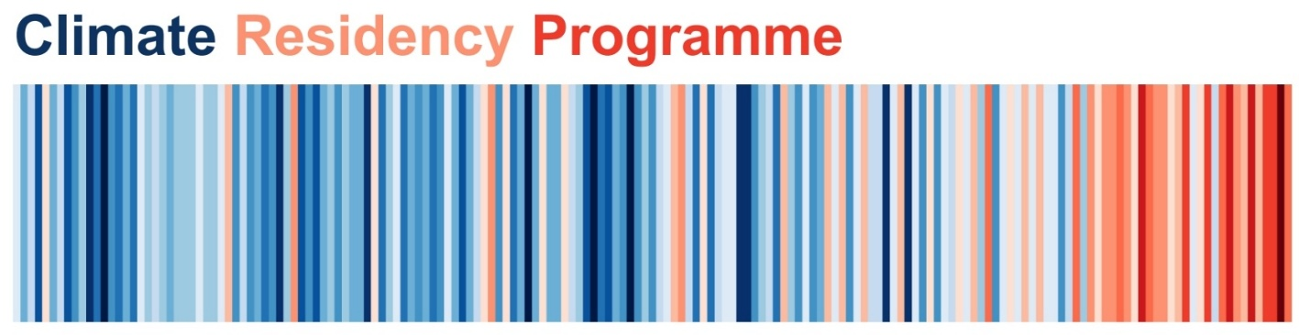

PARTNER ORGANIZATIONS


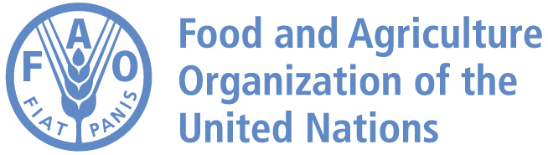



PROGRAMME
“Science, Innovation and Cooperation for a Climate-Resilient Central Asia”

DATE: 14 AUGUST 2026

VENUE: CENTRAL ASIAN UNIVERSITY OF ENVIRONMENTAL AND CLIMATE CHANGE STUDIES (GREEN UNIVERSITY),
2, CHIMKENT ROAD, DARKHAN HAMLET, TASHKENT DISTRICT, TASHKENT PROVINCE, 111104, UZBEKISTAN

TIME | PROGRAMME
09:00–09:30 | Registration and morning coffee
OPENING SESSION
Chaired by: Mr Jakhongir Babadjanov – Technical Expert, FAO

09:30–10:00 | Opening remarks by:  - H.E. Aziz A. Abdukhakimov – Advisor to the President of the Republic of Uzbekistan on Environmental Issues, Chairman of the National Committee on Ecology and Climate Change of the Republic of Uzbekistan  - Mr Sherzod Umarov – FAO Assistant Representative  - H.E. Antti Karttunen – Ambassador, Head of the OSCE Project Co-ordinator in  - Uzbekistan  - Dr. Ismail Belen – Chief Inspector, General Directorate of Combating Desertification and Erosion, Ministry of Forestry and Water Affairs  Setting the Stage  - Prof. Dr. Bakhtiyor Pulatov – Rector, Central Asian University of Environmental and Climate Change Studies (Green University)
10:00–10:20 | Keynote Speech  Prof. Dr. Rik Leemans – Wageningen University and Research, the Netherlands  - Past and recent development in climate-change scenarios and their applications
10:20–10:40 | Presentation of the Climate Residency Programme  Mr. Shakhboz Akhmedov – Director of Climate Residency Programme, Green University
10:40–11:10 | Group photo & Coffee break
SESSION I: The Science–Policy Interface – Turning Climate Evidence into Policy and Regional Cooperation
Chaired by: Mr. Shakhboz Akhmedov – Director of Climate Residency Programme, Green University

11:10–12:10 | - Dr. Jusipbek Kazbekov – Deputy Chairman of the National Committee on Ecology and Climate Change of the Republic of Uzbekistan  - Dr. Iskandar Abdullaev – Senior Researcher, International Water Management Institute (IWMI)  - Mr. Marco Keiner, Executive Director, Futurefinder – Solutions for a better world (online)  - Mr. Jurgen Keinhorst, Director, Eastern Europe and Central Asia; Africa and Middle East, Federal Ministry for the Environment, Germany (former)  - Dr. Ismail Belen – Chief Inspector, General Directorate of Combating Desertification and Erosion, Ministry of Forestry and Water Affairs
12:10–12:20 | Q&A session
SPECIAL SESSION: Ceremony of Signing MoU & Youth Initiatives
Chaired by: Mr Furkat Charangaev – Head of Department, Green University
12:20–13:00 | - Signing MoU with FAO (Central Asia Climate Leadership Programme)  - Signing MoU with Ismail Belen (Combating Desertification)  Announcement of the Central Asian Climate Leadership Programme  - Mr Azamat Kauazov, Manager of Climate Change and Sustainable Energy Programme, CAREC  - Prof. Dr. Christopher Gerry – Rector University of Central Asia, Kyrgyz Republic  - Ms Raikhona Dadakhanova – Youth Focal Point, FAO
13:00–14:00 | Lunch & Networking
SESSION II: Aral Sea Wetlands and Water Diplomacy in Central Asia
Chaired by: Amb. Javlon Vakhabov – Deputy Advisor to the President, Managing Director at The International Institute for Central Asia
14:00–15:00 | - Prof. Dr. Malika Ikramova – Research Institute of Irrigation and Water Problems  - Dr. Tolibjon Kudratov – Deputy Director, Research Institute of Irrigation and Water Problems  - Dr. Dinara Ziganshina – Director, Scientific Information Center of the Interstate Commission for Water Coordination in Central Asia (SIC ICWC)  - Prof. Dr. Abdulkhakim Salokhiddinov – Vice-Rector for International Cooperation, National Research University TIIAME  - Lobar Umarova – Chief Research Fellow, Institute for Strategic and Regional Studies under the President of the Republic of Uzbekistan (ISRS)
15:00–15:10 | Q&A session
SESSION III: Climate Change, Water, Agriculture and Energy – Technical and Earth-System Science Perspectives
Сhaired by: Dr. Ben Jarihani – Senior Lecturer, James Cook University, Australia and
15:10–16:10 | - Dr Abror Gafurov – Working Group Lead at GFZ Helmholtz Centre for Geosciences  - Prof. Dr. Ali Torabi, Water Resources and Environmental Engineering, University of Oulu  - Prof. Dr. Fadong Li – Institute of Geographic Sciences and Natural Resources Research, Chinese Academy of Sciences, China  - Prof. Dr. James Terry – Zayed University, United Arab Emirates  - Dr. Jafar Niyazov – Institute of Water Problems, Hydropower and Ecology, Tajikistan
16:10–16:20 | Q&A session
16:20–16:35 | Coffee break
SESSION IV: Innovation, Circular Economy and Regional Cooperation for Climate Resilience
Chaired by: Mr Jakhongir Babadjanov – Technical Expert, FAO

16:35–17:35 | - Dr. Abooali Golzary, Lecturer, Department of Environmental Engineering, University of Tehran, Tehran, Iran  - Dr. Kanat Sultanaliev – American University of Central Asia, Kyrgyz Republic  - Mr Stephan Robinson, International Expert, FAO  - Prof. Li Yaoming, Director of the Research Center of Green Development of Silk Road, Xinjiang Institute of Ecology and Geography, Chinese Academy of Sciences  - Mr Botir Khaitov, Technical expert, FAO
17:35–17:45 | Q&A session
17:45–18:00 | Closing remarks  Prof. Dr. Bakhtiyor Pulatov – Rector, Central Asian University of Environmental and Climate Change Studies (Green University)
19:00 | Dinner (by invitation)

